EXP: 1

- Create a table name STUDENT with following structure.
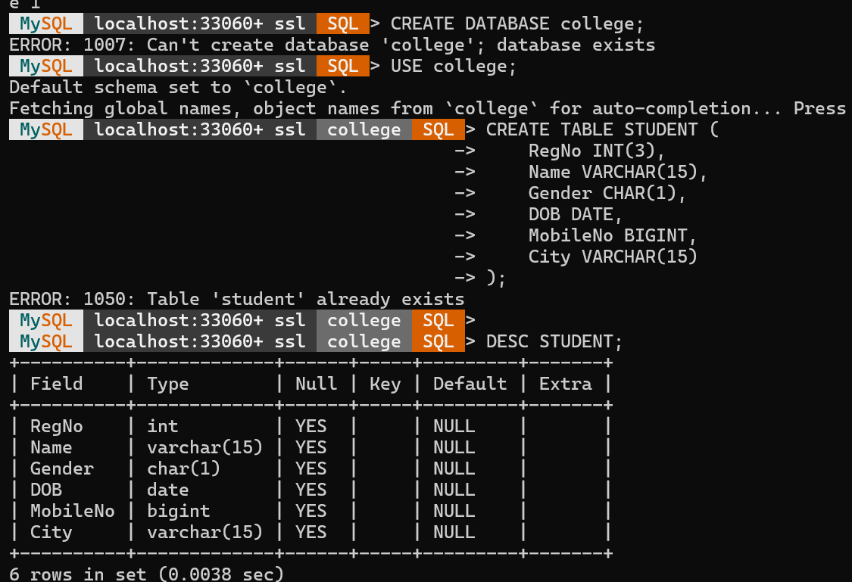
- Create a table name FACULTY with following structure.
- Create a table name DEPARTMENT with following structure.
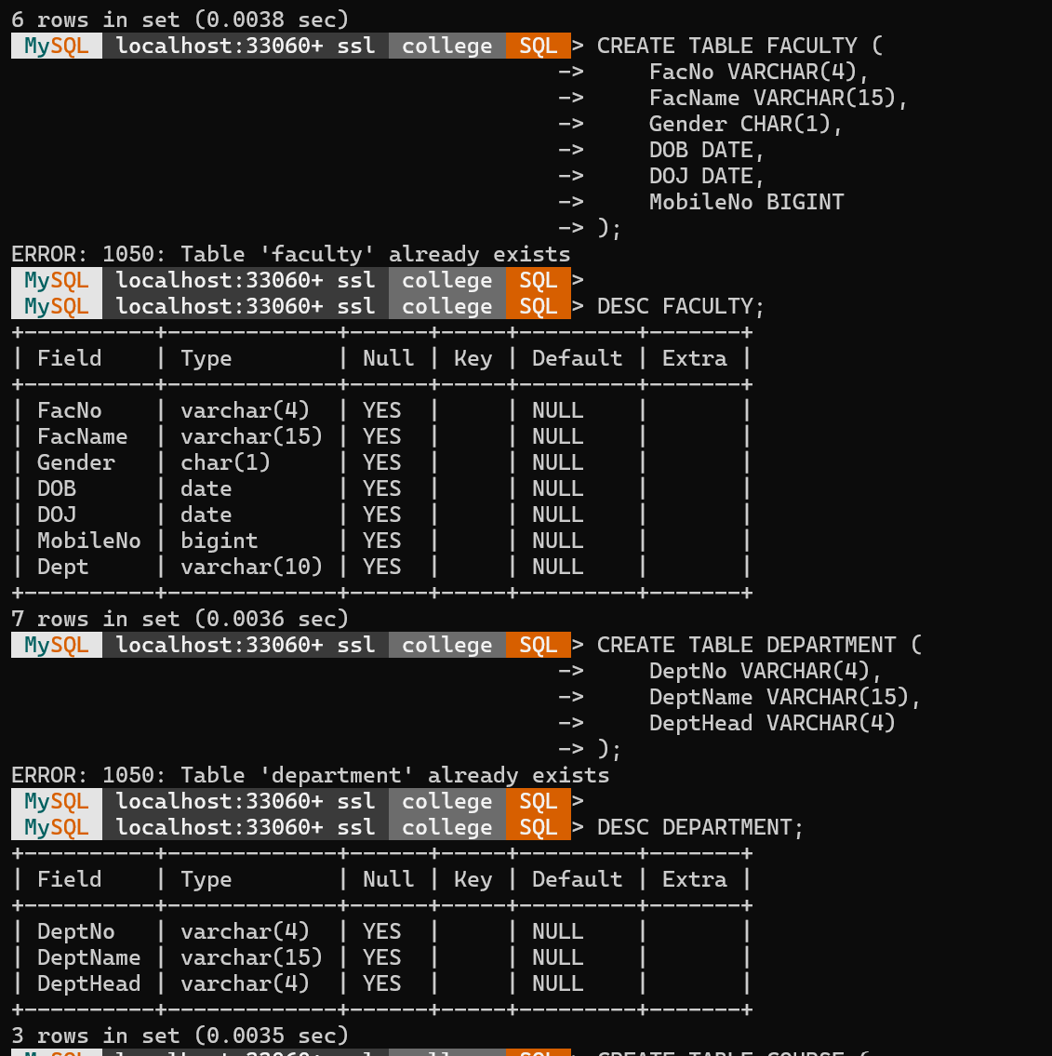
4) Create a table name COURSE with following structure.
5) Modify the table FACULTY by adding a column name Dept of datatype VARCHAR(10)
